Grwtgrwt

s(Krugman, Obstfeld and Melitz, International Economics, 2012, Chapter 13)

(Krugman, Obstfeld and Melitz, International Economics, 2012, Chapter 13)

(Krugman, Obstfeld and Melitz, International Economics, 2012, Chapter 13)

ECO3702: Advanced Macroeconomics Lecture Note 4:

2017

Twin Deficit

**Kaan Öğüt**

# Krugman, Obstfeld and Melitz, International Economics, 2012, Chapter 13

# Understanding Capital And Financial Accounts In The Balance Of Payments. By [Reem Heakal](http://www.investopedia.com/contributors/80/)

# What Is The Balance Of Payments? By [Reem Heakal](http://www.investopedia.com/contributors/80/)

Bahçeşehir unıversıty

**Current Account and International Borrowing.**

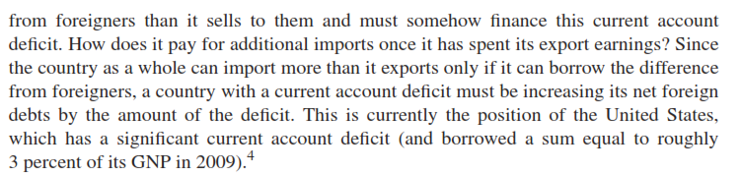

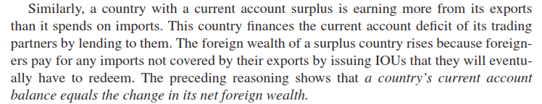

The Current Account and Foreign Indebtedness

* + **Current account (*CA*) balance**
    - The difference between exports of goods and services and imports of goods and services (*CA* = *EX* – *IM*)
    - A country has a *CA* surplus when its *CA* > 0.
    - A country has a *CA* deficit when its *CA* < 0.
    - *CA* also measures the size and direction of international borrowing.
      * A country’s current account balance equals the change in its net foreign wealth.

When current account is deficit, net foreign wealth is decreasing or foreign debt is increasing.

$CA<0→\frac{d\left({DEBT}^{foreign}\right)}{dt}>0$

**Saving - Investment and Current Account:**

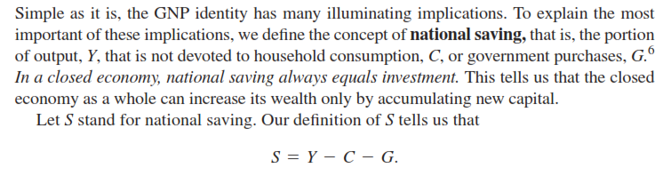



Actually even if the economy is closed, investment - saving equivalence may not be achieved. It is possible to borrow from future income to finance current investment. Also saving can be used to acquisition of wealth



 

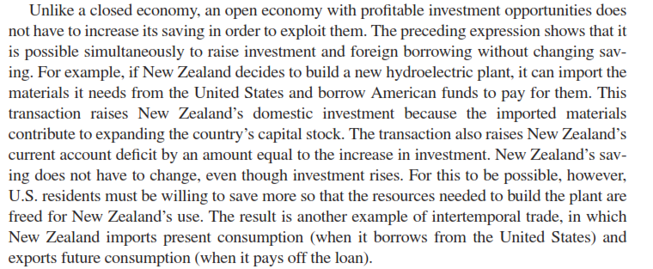

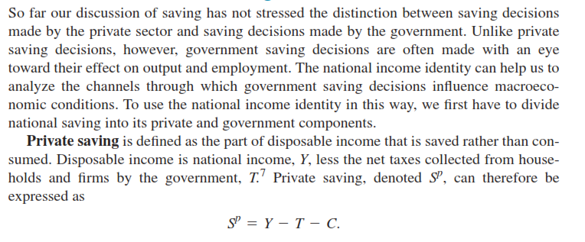

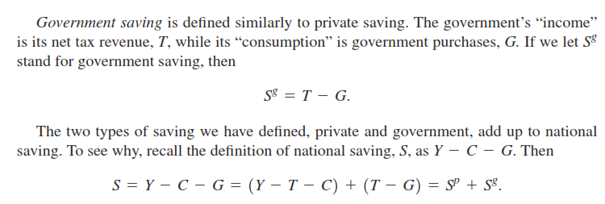

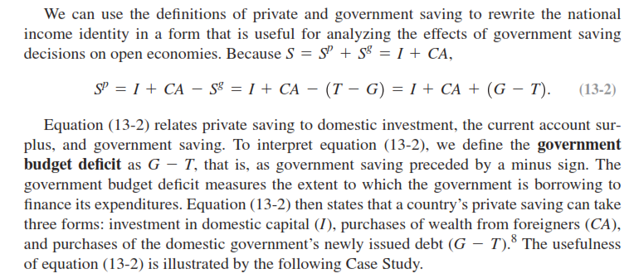















**Components of Financial Accounts**

**Investment:**

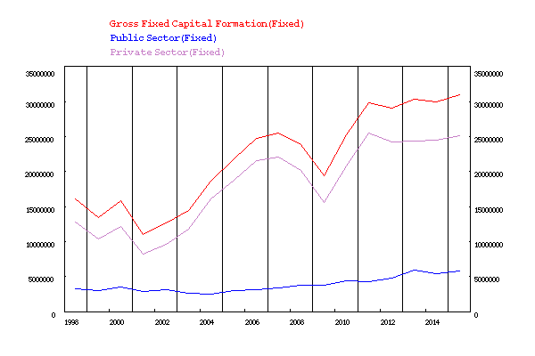

**Growth rates of GDP and Investment (quarterly):**

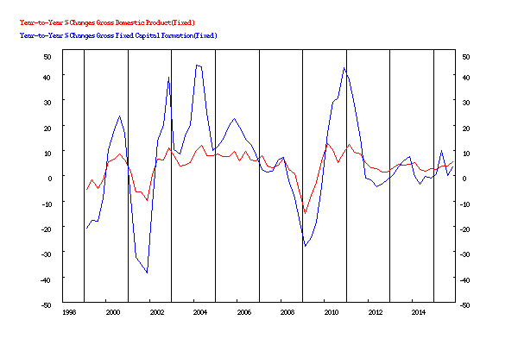

**Growth rates of GDP and Investment (annually):**

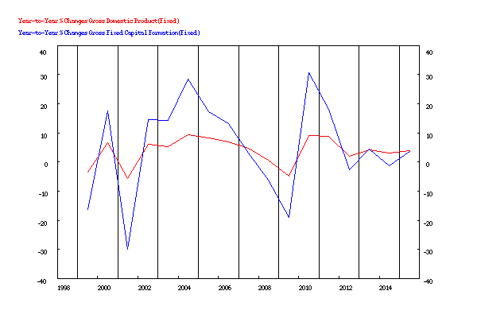

1999 -3.37 -16.21

2000 6.77 17.47

2001 -5.70 -29.97

2002 6.16 14.68

2003 5.27 14.17

2004 9.36 28.36

2005 8.40 17.39

2006 6.89 13.26

2007 4.67 3.10

2008 0.66 -6.16

2009 -4.83 -19.05

2010 9.16 30.54

2011 8.77 18.03

2012 2.13 -2.70

2013 4.19 4.37

2014 3.02 -1.33

2015 3.98 3.61

INFO ON CHOSEN SERIES

Year-to-Year % Changes Gross Domestic Product(Fixed)

Year-to-Year % Changes Gross Fixed Capital Formation(Fixed)

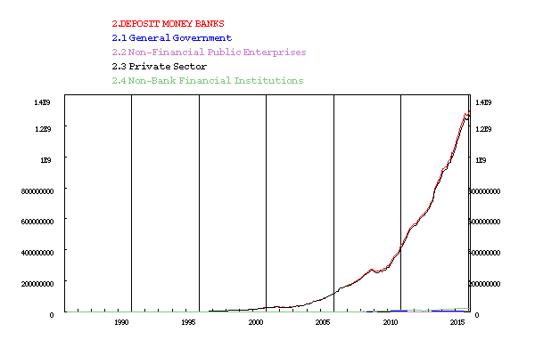

**Twin Deficits:**



In 1980s **defense expenditures** started to increase and **income tax rates were declined** by the Reagan administration. (Reagan administration’s Economic Recovery Act of 1981 sharply cut income tax rates, leading to a 2% decline in tax revenue)

After that government budget deficit went from under 2% of GDP to 6% of GDP. Simultaneously US economy began to display trade deficit (probably dollar appreciation triggered trade deficit too).

This situation (**co existence of budget and trade deficits together**) has been called as “**twin deficits**” Twin deficits have been observed since the beginning of the new century.







High output growth and dollar appreciation during the early 1980s resulted in an increase in the trade deficit. A higher trade deficit, combined with a large budget deficit, became known as the **twin deficits** of the 1980s

However in the late 1990s and early 2000s during the Clinton administration **while the budget went into surplus, the trade deficit continued to rise.** Hypothesis can not explain this period. Indeed in the late 1990s, **private saving declined**, while investment surged during the boom of the late 1990s.



Some economists claim that these two events related **and budget deficit is the primary cause of the current account deficit.** According to twin deficits hypothesis **government deficit pushes up the interest rate and this attracts foreign capital inflows that causes appreciation of the domestic currency and the result is a trade and current account deficit**.

$$S^{p}=I+CA+\left(G-T\right)$$

$$CA=S^{p}-I-(G-T)$$

According to equation **if the government deficit rises (G-T) goes up** and private saving and investment don’t change much **current account surplus must fall**. On the other hand equation says that **when changes in government deficits lead to change in private saving and investment behavior** conclusion can be different and CA may not be affected.

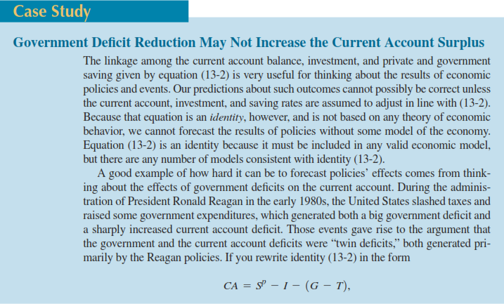

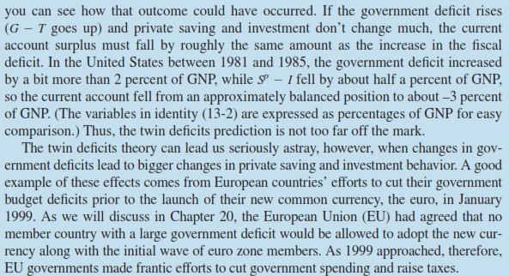

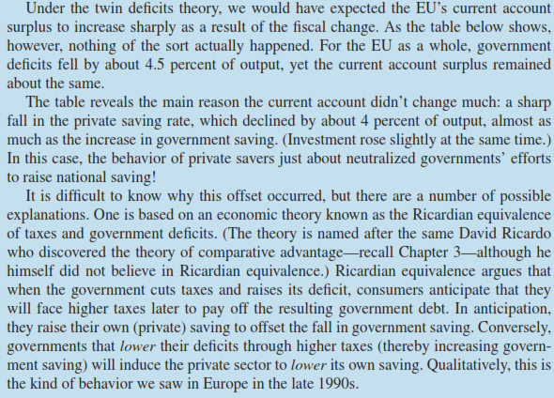

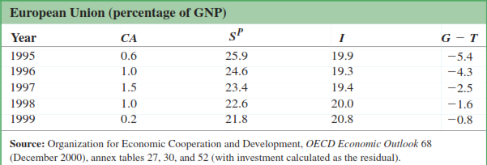

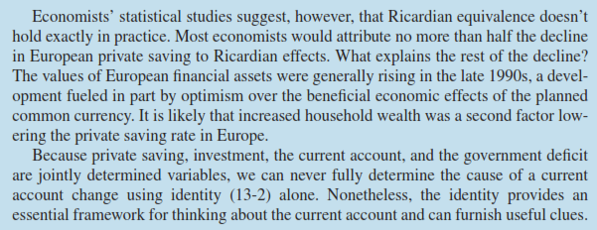

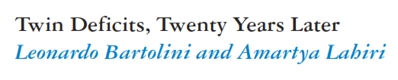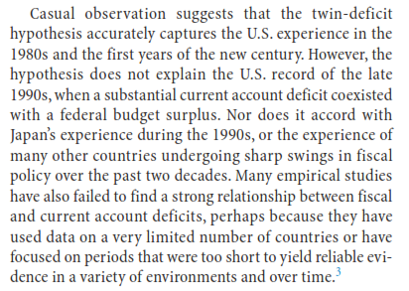

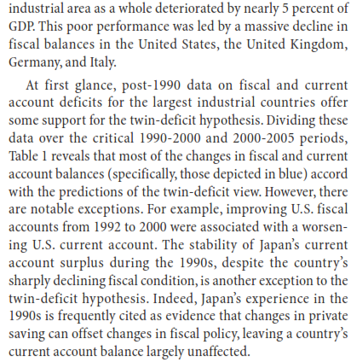

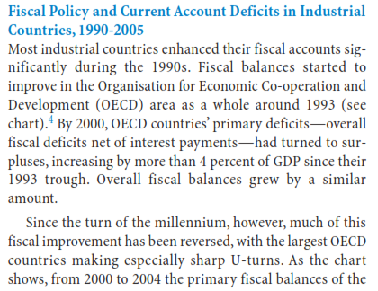



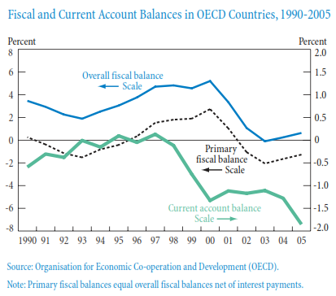

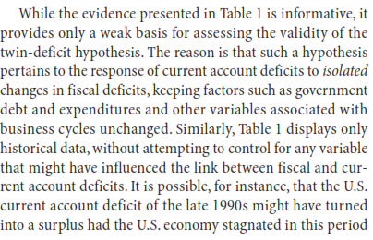

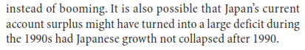

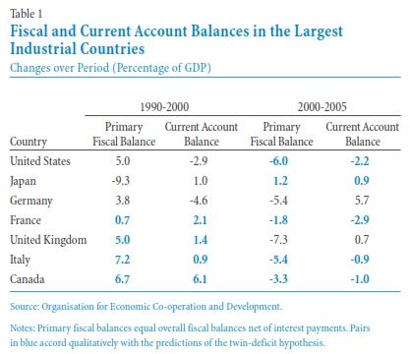

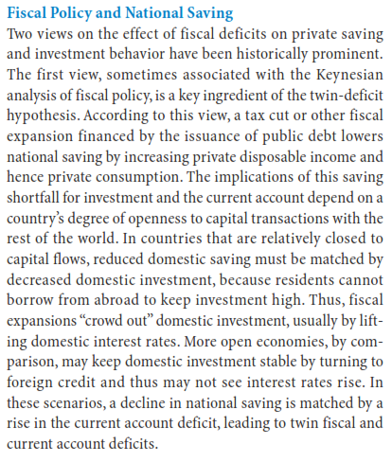

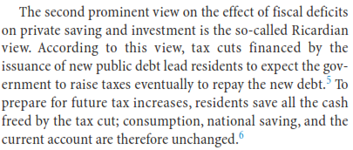

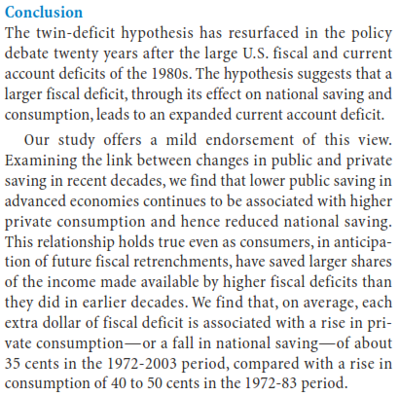

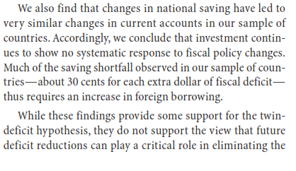

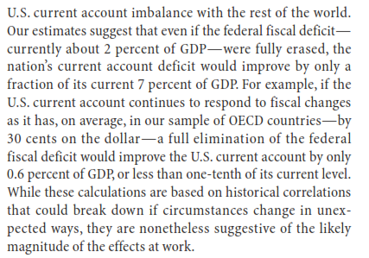

Last year Morgan Stanley coined the phrase the “Fragile Five,” lumping South Africa together with India, Brazil, Indonesia and Turkey as being the countries that were most at risk when the Federal Reserve started tapering off its Quantitative Easing program. But is it fair for South Africa to be lumped together with these other economies, as being susceptible to a flight of foreign capital when the injection of cheap money inevitably comes to an end?

[[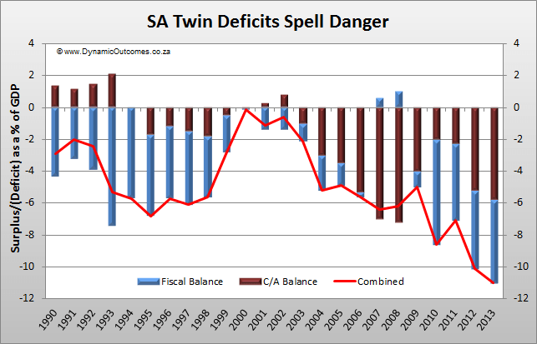](http://www.forexforecasts.co.za/images/SA-Twin-Deficits-Spell-Danger.png?placeValuesBeforeTB_=savedValues&TB_iframe=true&height=635&width=1310)Click to see full size...](http://www.forexforecasts.co.za/images/SA-Twin-Deficits-Spell-Danger.png?placeValuesBeforeTB_=savedValues&TB_iframe=true&height=635&width=1310)

The chart shows a history of the Current Account (what the country receives from trade of goods, services and investments offshore, less what it spends) as well as the Fiscal (Budget) Account (what the government earns in taxes, less what it spends), both reflected as a percentage of GDP.  
  
As you can clearly see, in 2000 there was a zero Combined deficit, but since then the situation has steadily deteriorated to the point where 2013 recorded a Combined deficit of 11% of GDP!  
  
Well, if you spend 11% more than you earn, you need to borrow to make up the shortfall. Fortunately, because of low interest rates overseas, foreigners have been happy to bring their money into our markets (to earn a *premium return*). 

Top of Form

Bottom of Form

# [Paul Krugman - New York Times Blog](http://krugman.blogs.nytimes.com/?module=BlogMain&action=Click&region=Header&pgtype=Blogs&version=Blog%20Post&contentCollection=Opinion)

 MARCH 28, 2013

**Twins No More**

Back in the Reagan years two unprecedented things began happening to the US economy. For the first time ever, we began running **large peacetime budget deficits**; and for the first time ever we began running **large trade deficits**. In a famous analysis, Martin Feldstein pronounced them “twin deficits”, linking the external deficit to the budget deficit, a proposition that made sense at the time: **the budget deficit was helping to drive up interest rates, and high rates led to an overvalued dollar**.

It’s occurred to me recently that much discussion of deficits these days implicitly assumes that something similar applies in today’s world — that by running budget deficits we’re indebting ourselves, as a nation, to foreigners (especially China). So it’s worth pointing out that this isn’t remotely true.

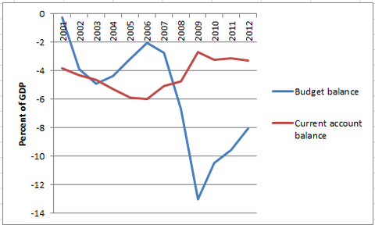

The budget balance here is for “general government” — federal, state, and local; the current account is the broad definition of trade, including investment income. What you see is that the **surge in budget deficits after 2008 was accompanied by a significant decline in net foreign borrowing** compared with the height of the housing bubble.

There’s no mystery here, of course: what **happened in the slump was a collapse in private spending**, which actually brought the trade deficit down even as it led to a sharp fall in revenue and rise in spending on safety-net programs.

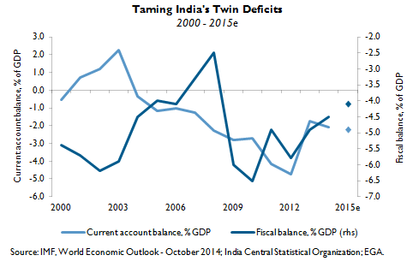

**India’s twin deficits.** The Indian economy is no stranger to twin current and fiscal account deficits. In 2012, the deficits reached perilous levels as the fiscal deficit rose to 5.8% of [gross domestic product](http://www.emergingglobaladvisors.com/glossary.cfm) (GDP) and the current account deficit stood at 4.7% of GDP. Deficits need to be financed and their reversal depends on better economic management.

**Improving economic management.**The deficits have improved modestly since 2012, but more work needs to be done. Under Prime Minister Modi, the Indian government has promoted reforms to reduce subsidies, attract foreign investment, privatize some state-owned companies, improve infrastructure, and rationalize the tax system. These reforms should attract investment and accelerate growth. Additionally, lower crude oil prices should cut India’s import bill and continue to shrink the deficits, as well as improve the rate of economic growth. 

The following chart (courtesy of Goldman Sachs) shows the “twin deficits” (fiscal and current account) of the PIIGS countries for the last four quarters:

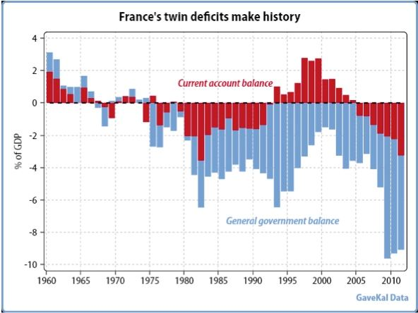

**What About Turkey**